I see you are progressing well. Only a couple more to go. Just because a password is random doesn’t make it secure, it still needs to have enough characters too. 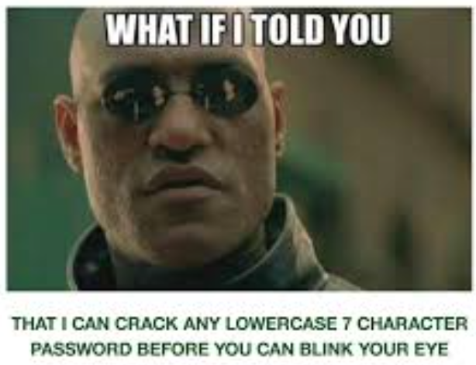
This next password is just 8 random digits, so it won’t be enough to stop you. 16 would probably do. Too bad I only used 8. You’ll also have to find a way to crack the hash even though I’m just giving you the pdf. I hear the guy John that you met in the last challenge should also be able to help you with this! What a helpful guy… good luck!

